Figure 6
Connections over 200 kbps in at Least One Direction 2014-2018
(In thousands)

 | 2014 | 2015 |  | 2016 |  | 2017 |  | 2018
Technology | Dec | Jun | Dec | Jun | Dec | Jun | Dec | Jun | Dec
Total | 338,202 | 357,613 | 375,895 | 395,604 | 404,971 | 408,816 | 420,973 | 428,983 | 441,397
Total Fixed | 98,245 | 100,179 | 102,216 | 104,088 | 105,715 | 106,254 | 108,200 | 109,207 | 110,866
Mobile Wireless | 239,957 | 257,434 | 273,679 | 291,516 | 299,256 | 302,562 | 312,773 | 319,776 | 330,531

Figure 7
Residential Connections over 200 kbps in at Least One Direction 2014-2018
(In thousands)

 | 2014 | 2015 |  | 2016 |  | 2017 |  | 2018
Technology | Dec | Jun | Dec | Jun | Dec | Jun | Dec | Jun | Dec
Total | 290,696 | 306,292 | 322,557 | 330,987 | 337,978 | 341,094 | 351,964 | 358,851 | 368,473
Total Fixed | 89,530 | 91,439 | 93,434 | 95,001 | 96,607 | 97,072 | 98,843 | 99,742 | 101,283
Mobile Wireless | 201,166 | 214,853 | 229,122 | 235,985 | 241,371 | 244,022 | 253,121 | 259,109 | 267,191

Some previously published data may have been revised. Figures may not sum to totals due to rounding.

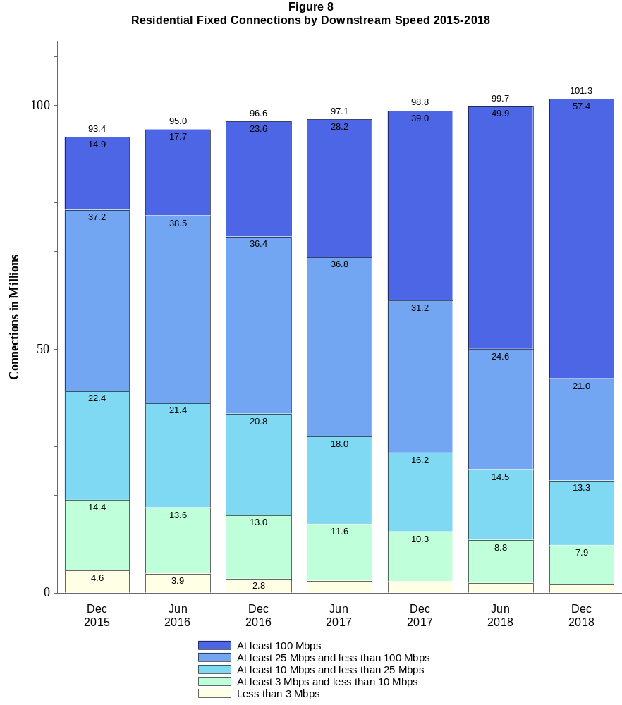

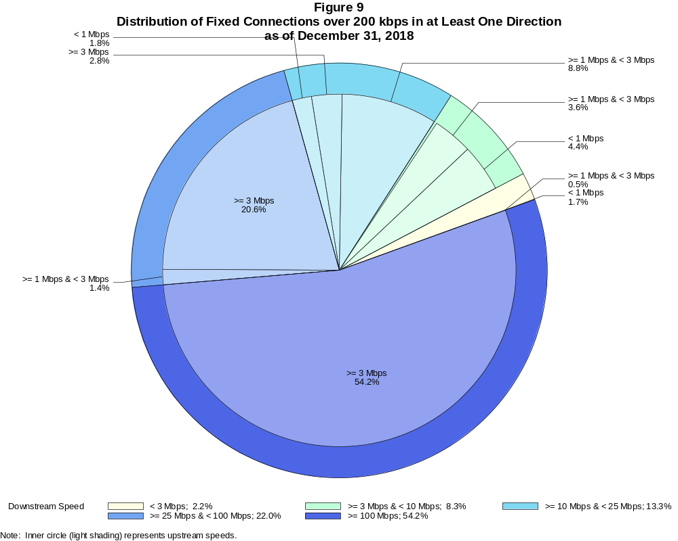

Fixed Connections over 200 kbps in at Least One Direction (in thousands)

 | Downstream Speed
Upstream Speed | Less than 3 Mbps | At least 3 Mbps  and less than 10 Mbps | At least 10 Mbps  and less than 25 Mbps | At least 25 Mbps  and less than 100 Mbps | At least 100 Mbps | Total
Less than 1 Mbps | 1,883 | 4,826 | 1,961 | # | # | 8,669
At least 1 Mbps & Less than 3 Mbps | 511 | 4,040 | 9,728 | 1,560 | 6 | 15,846
At least 3 Mbps | 5 | 285 | 3,085 | 22,843 | 60,131 | 86,350
Total | 2,399 | 9,151 | 14,774 | 24,404 | 60,137 | 110,866

Percentages

Less than 1 Mbps | 1.7 | 4.4 | 1.8 | 0.0 | 0.0 | 7.8
At least 1 Mbps & Less than 3 Mbps | 0.5 | 3.6 | 8.8 | 1.4 | 0.0 | 14.3
At least 3 Mbps | 0.0 | 0.3 | 2.8 | 20.6 | 54.2 | 77.9
Total | 2.2 | 8.3 | 13.3 | 22.0 | 54.2 | 100.0

Note: Figures may not sum to totals due to rounding. # = Rounds to zero.
Source: FCC Form 477.

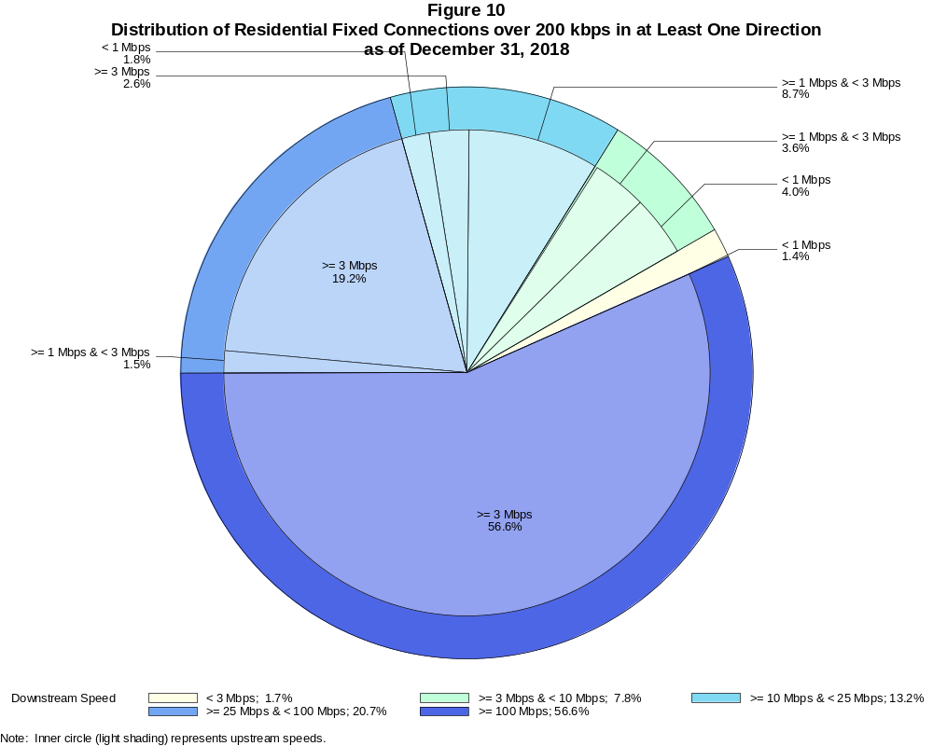

Residential Fixed Connections over 200 kbps in at Least One Direction (in thousands)

 | Downstream Speed
Upstream Speed | Less than 3 Mbps | At least 3 Mbps  and less than 10 Mbps | At least 10 Mbps  and less than 25 Mbps | At least 25 Mbps  and less than 100 Mbps | At least 100 Mbps | Total
Less than 1 Mbps | 1,441 | 4,078 | 1,845 | # | # | 7,364
At least 1 Mbps & Less than 3 Mbps | 261 | 3,682 | 8,804 | 1,502 | 6 | 14,254
At least 3 Mbps | 5 | 157 | 2,676 | 19,458 | 57,368 | 79,665
Total | 1,707 | 7,916 | 13,325 | 20,961 | 57,374 | 101,283

Percentages

Less than 1 Mbps | 1.4 | 4.0 | 1.8 | 0.0 | 0.0 | 7.3
At least 1 Mbps & Less than 3 Mbps | 0.3 | 3.6 | 8.7 | 1.5 | 0.0 | 14.1
At least 3 Mbps | 0.0 | 0.2 | 2.6 | 19.2 | 56.6 | 78.7
Total | 1.7 | 7.8 | 13.2 | 20.7 | 56.6 | 100.0

Note: Figures may not sum to totals due to rounding. # = Rounds to zero.
Source: FCC Form 477.

Figure 11
Connections over 200 kbps in at Least One Direction by Technology 2014-2018
(In thousands)

 | 2014 | 2015 |  | 2016 |  | 2017 |  | 2018
Technology | Dec | Jun | Dec | Jun | Dec | Jun | Dec | Jun | Dec
Total | 338,202 | 357,613 | 375,895 | 395,604 | 404,971 | 408,816 | 420,973 | 428,983 | 441,397
Total Fixed | 98,245 | 100,179 | 102,216 | 104,088 | 105,715 | 106,254 | 108,200 | 109,207 | 110,866
aDSL | 29,533 | 29,351 | 28,134 | 27,488 | 26,527 | 25,506 | 24,193 | 23,072 | 21,932
sDSL | 72 | 77 | 60 | 55 | 42 | 44 | 28 | 28 | 20
Other Wireline¹ | 773 | 706 | 694 | 674 | 655 | 668 | 630 | 610 | 600
Cable Modem | 55,785 | 57,244 | 59,706 | 61,456 | 63,325 | 64,060 | 66,196 | 67,163 | 68,857
FTTP² | 9,077 | 9,688 | 10,498 | 11,143 | 12,053 | 12,906 | 13,978 | 14,982 | 16,021
Satellite | 2,006 | 2,058 | 2,071 | 2,079 | 1,864 | 1,826 | 1,872 | 1,939 | 1,971
Fixed Wireless | 999 | 1,056 | 1,054 | 1,192 | 1,250 | 1,245 | 1,304 | 1,414 | 1,465
Mobile Wireless | 239,957 | 257,434 | 273,679 | 291,516 | 299,256 | 302,562 | 312,773 | 319,776 | 330,531

¹ Power Line and Other are summarized with Other Wireline to maintain firm confidentiality. See Technical Notes at the end of the report for a description of
Form 477 technology categories and other reporting requirements.
² Fiber to the premises.
Some previously published data may have been revised. Figures may not sum to totals due to rounding.

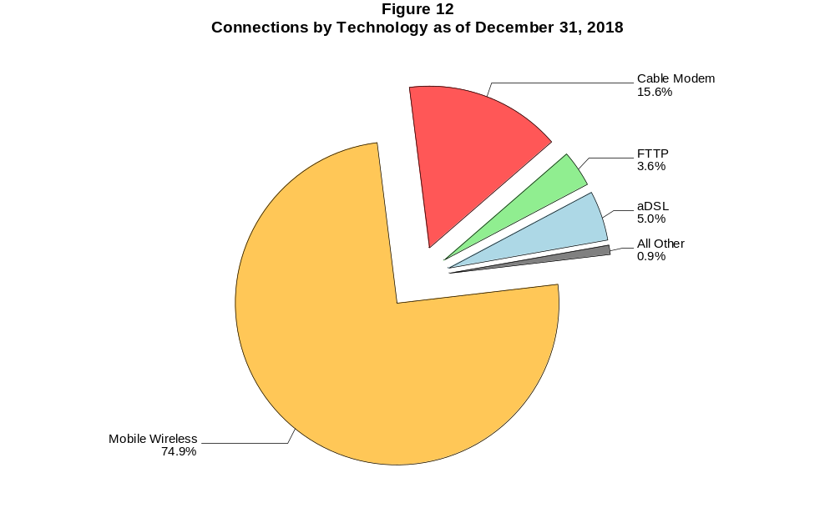

Figure 13
Residential Connections over 200 kbps in at Least One Direction by Technology 2014-2018
(In thousands)

 | 2014 | 2015 |  | 2016 |  | 2017 |  | 2018
Technology | Dec | Jun | Dec | Jun | Dec | Jun | Dec | Jun | Dec
Total | 290,696 | 306,292 | 322,557 | 330,987 | 337,978 | 341,094 | 351,964 | 358,851 | 368,473
Total Fixed | 89,530 | 91,439 | 93,434 | 95,001 | 96,607 | 97,072 | 98,843 | 99,742 | 101,283
aDSL | 26,442 | 26,157 | 25,139 | 24,486 | 23,691 | 22,775 | 21,653 | 20,670 | 19,691
sDSL | 19 | 18 | 16 | 10 | 8 | 12 | 9 | 9 | 4
Other Wireline¹ | 59 | 59 | 54 | 51 | 32 | 74 | 67 | 74 | 74
Cable Modem | 52,061 | 53,544 | 55,799 | 57,358 | 59,145 | 59,687 | 61,567 | 62,318 | 63,788
FTTP² | 8,262 | 8,842 | 9,592 | 10,140 | 10,956 | 11,776 | 12,702 | 13,661 | 14,621
Satellite | 1,803 | 1,875 | 1,891 | 1,897 | 1,676 | 1,637 | 1,688 | 1,751 | 1,787
Fixed Wireless | 884 | 944 | 943 | 1,059 | 1,099 | 1,111 | 1,156 | 1,260 | 1,318
Mobile Wireless | 201,166 | 214,853 | 229,122 | 235,985 | 241,371 | 244,022 | 253,121 | 259,109 | 267,191

¹ Power Line and Other are summarized with Other Wireline to maintain firm confidentiality. See Technical Notes at the end of the report for a description of
Form 477 technology categories and other reporting requirements.
² Fiber to the premises.
Some previously published data may have been revised. Figures may not sum to totals due to rounding.

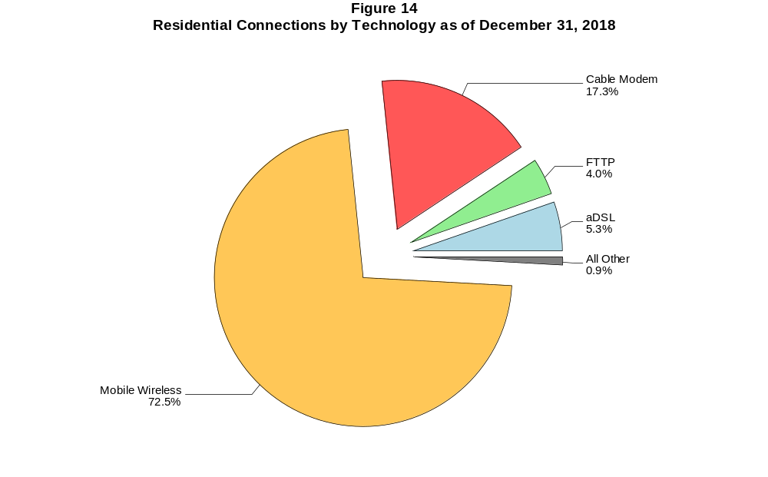

Figure 15
Fixed Connections at Least 3 Mbps Downstream and 768 kbps Upstream by Technology 2014-2018
(In thousands)

 | 2014 | 2015 |  | 2016 |  | 2017 |  | 2018
Technology | Dec | Jun | Dec | Jun | Dec | Jun | Dec | Jun | Dec
Total | 83,872 | 89,011 | 92,356 | 95,517 | 98,761 | 100,098 | 102,047 | 104,054 | 106,183
aDSL | 18,557 | 20,947 | 20,744 | 21,147 | 21,042 | 20,621 | 19,257 | 18,874 | 18,123
sDSL | 28 | 24 | 20 | 20 | 20 | 24 | 16 | 17 | 11
Other Wireline¹ | 308 | 297 | 330 | 336 | 328 | 355 | 369 | 376 | 386
Cable Modem | 53,853 | 55,819 | 58,423 | 60,343 | 62,855 | 63,719 | 65,906 | 66,959 | 68,681
FTTP² | 8,974 | 9,552 | 10,383 | 11,030 | 11,953 | 12,813 | 13,870 | 14,889 | 15,929
Satellite | 1,558 | 1,690 | 1,744 | 1,775 | 1,609 | 1,586 | 1,563 | 1,722 | 1,770
Fixed Wireless | 594 | 681 | 712 | 865 | 954 | 981 | 1,065 | 1,216 | 1,285

¹ Power Line and Other are summarized with Other Wireline to maintain firm confidentiality. See Technical Notes at the end of the report for a description of Form
477 technology categories and other reporting requirements.
² Fiber to the premises.
# = Rounds to zero.
Some previously published data may have been revised. Figures may not sum to totals due to rounding.

Figure 16
Residential Fixed Connections at Least 3 Mbps Downstream and 768 kbps Upstream by Technology 2014-2018
(In thousands)

 | 2014 | 2015 |  | 2016 |  | 2017 |  | 2018
Technology | Dec | Jun | Dec | Jun | Dec | Jun | Dec | Jun | Dec
Total | 77,540 | 82,320 | 85,439 | 88,198 | 91,258 | 92,355 | 93,987 | 95,741 | 97,637
aDSL | 16,867 | 18,988 | 18,866 | 19,207 | 19,133 | 18,719 | 17,480 | 17,127 | 16,461
sDSL | 2 | 1 | 2 | 2 | 2 | 7 | 6 | 6 | 2
Other Wireline¹ | 50 | 45 | 47 | 49 | 31 | 73 | 66 | 72 | 71
Cable Modem | 50,308 | 52,254 | 54,650 | 56,353 | 58,784 | 59,411 | 61,335 | 62,165 | 63,657
FTTP² | 8,246 | 8,750 | 9,512 | 10,063 | 10,883 | 11,704 | 12,616 | 13,588 | 14,548
Satellite | 1,552 | 1,682 | 1,734 | 1,764 | 1,596 | 1,571 | 1,545 | 1,700 | 1,745
Fixed Wireless | 516 | 599 | 628 | 759 | 830 | 870 | 940 | 1,082 | 1,154

¹ Power Line and Other are summarized with Other Wireline to maintain firm confidentiality. See Technical Notes at the end of the report for a description of Form
477 technology categories and other reporting requirements.
² Fiber to the premises.
# = Rounds to zero.
Some previously published data may have been revised. Figures may not sum to totals due to rounding.

Figure 17
Fixed Connections at Least 10 Mbps Downstream and 1 Mbps Upstream by Technology 2014-2018
(In thousands)

 | 2014 | 2015 |  | 2016 |  | 2017 |  | 2018
Technology | Dec | Jun | Dec | Jun | Dec | Jun | Dec | Jun | Dec
Total | 68,238 | 72,713 | 76,939 | 80,458 | 84,112 | 86,967 | 90,703 | 94,148 | 97,354
aDSL | 8,560 | 9,471 | 9,799 | 10,349 | 10,810 | 11,321 | 11,595 | 11,817 | 11,861
sDSL | 6 | 9 | 8 | 8 | 10 | 14 | 9 | 11 | 6
Other Wireline¹ | 186 | 182 | 203 | 210 | 217 | 253 | 273 | 282 | 302
Cable Modem | 49,837 | 52,658 | 55,710 | 57,951 | 60,349 | 61,704 | 63,978 | 65,807 | 67,691
FTTP² | 8,320 | 8,874 | 9,575 | 10,143 | 11,001 | 11,884 | 12,954 | 13,988 | 15,074
Satellite | 1,136 | 1,298 | 1,393 | 1,467 | 1,342 | 1,373 | 1,402 | 1,595 | 1,677
Fixed Wireless | 193 | 221 | 252 | 330 | 383 | 418 | 492 | 649 | 743

¹ Power Line and Other are summarized with Other Wireline to maintain firm confidentiality. See Technical Notes at the end of the report for a description of
Form 477 technology categories and other reporting requirements.
² Fiber to the premises.
# = Rounds to zero.
Some previously published data may have been revised. Figures may not sum to totals due to rounding.

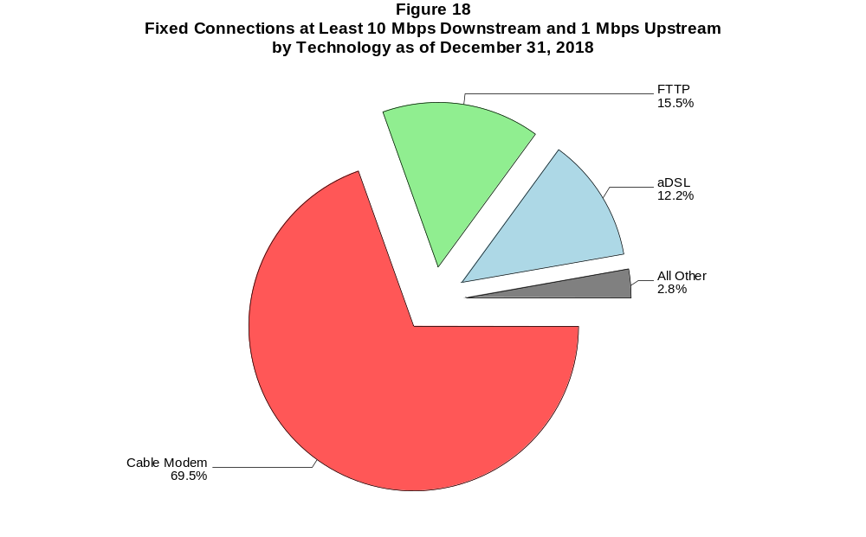

Figure 19
Residential Fixed Connections at Least 10 Mbps Downstream and 1 Mbps Upstream
by Technology 2014-2018
(In thousands)

 | 2014 | 2015 |  | 2016 |  | 2017 |  | 2018
Technology | Dec | Jun | Dec | Jun | Dec | Jun | Dec | Jun | Dec
Total | 63,732 | 67,898 | 71,784 | 74,841 | 78,202 | 80,671 | 84,164 | 86,959 | 89,815
aDSL | 7,970 | 8,743 | 9,069 | 9,526 | 9,963 | 10,415 | 10,657 | 10,859 | 10,902
sDSL | # | # | 1 | 2 | 2 | 6 | 5 | 6 | 2
Other Wireline¹ | 36 | 38 | 43 | 47 | 30 | 71 | 64 | 65 | 66
Cable Modem | 46,772 | 49,487 | 52,294 | 54,274 | 56,538 | 57,617 | 59,864 | 61,141 | 62,786
FTTP² | 7,653 | 8,144 | 8,776 | 9,248 | 10,004 | 10,835 | 11,762 | 12,739 | 13,742
Satellite | 1,133 | 1,293 | 1,386 | 1,460 | 1,333 | 1,362 | 1,387 | 1,575 | 1,655
Fixed Wireless | 167 | 191 | 213 | 283 | 332 | 365 | 426 | 574 | 661

¹ Power Line and Other are summarized with Other Wireline to maintain firm confidentiality. See Technical Notes at the end of the report for a description of
Form 477 technology categories and other reporting requirements.
² Fiber to the premises.
# = Rounds to zero.
Some previously published data may have been revised. Figures may not sum to totals due to rounding.

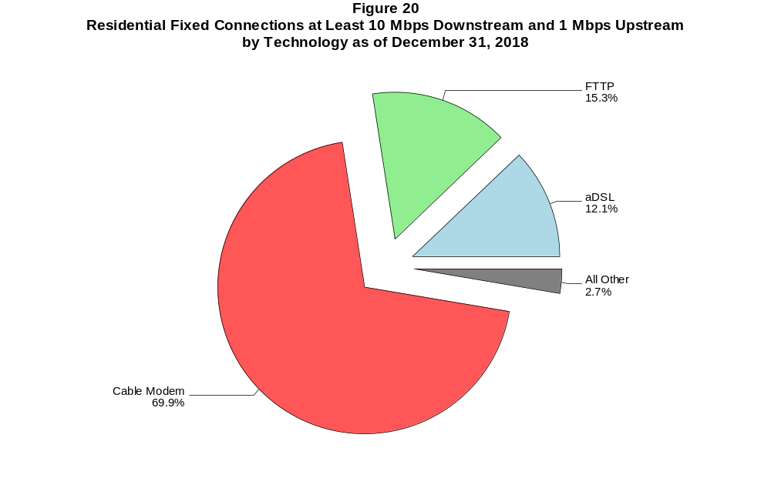

Figure 21
Fixed Connections at Least 25 Mbps Downstream and 3 Mbps Upstream by Technology 2014-2018
(In thousands)

 | 2014 | 2015 |  | 2016 |  | 2017 |  | 2018
Technology | Dec | Jun | Dec | Jun | Dec | Jun | Dec | Jun | Dec
Total | 42,713 | 48,784 | 54,335 | 58,753 | 62,907 | 68,041 | 73,331 | 78,175 | 81,956
aDSL | 587 | 762 | 938 | 1,239 | 1,476 | 2,530 | 3,586 | 4,297 | 4,837
sDSL | 1 | 1 | * | * | * | * | * | * | *
Other Wireline¹ | 125 | 125 | 141 | 158 | 170 | 207 | 224 | 209 | 233
Cable Modem | 36,383 | 40,979 | 45,530 | 48,696 | 51,740 | 54,829 | 57,870 | 60,858 | 62,853
FTTP² | 5,589 | 6,871 | 7,691 | 8,609 | 9,449 | 10,374 | 11,525 | 12,609 | 13,792
Satellite | # | # | * | * | * | * | * | * | *
Fixed Wireless | 28 | 47 | 55 | 72 | 92 | 120 | 146 | 222 | 261

¹ Power Line and Other are summarized with Other Wireline to maintain firm confidentiality. See Technical Notes at the end of the report for a description of
Form 477 technology categories and other reporting requirements.
² Fiber to the premises.
* = Data withheld to maintain firm confidentiality.
# = Rounds to zero.
Some previously published data may have been revised. Figures may not sum to totals due to rounding.

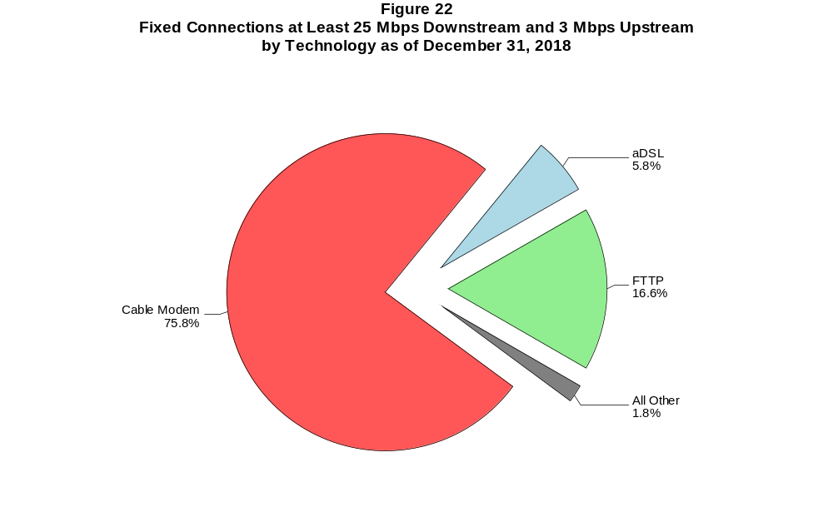

Figure 23
Residential Fixed Connections at Least 25 Mbps Downstream and 3 Mbps Upstream
by Technology 2014-2018
(In thousands)

 | 2014 | 2015 |  | 2016 |  | 2017 |  | 2018
Technology | Dec | Jun | Dec | Jun | Dec | Jun | Dec | Jun | Dec
Total | 40,916 | 46,532 | 51,788 | 55,694 | 59,463 | 64,253 | 68,871 | 72,480 | 75,829
aDSL | 556 | 727 | 897 | 1,173 | 1,408 | 2,418 | 3,410 | 4,067 | 4,563
sDSL | # | # | * | * | * | * | * | * | *
Other Wireline¹ | 26 | 26 | 31 | 41 | 27 | 67 | 59 | 54 | 59
Cable Modem | 35,202 | 39,416 | 43,746 | 46,527 | 49,300 | 52,154 | 54,748 | 56,619 | 58,316
FTTP² | 5,111 | 6,323 | 7,089 | 7,916 | 8,674 | 9,532 | 10,553 | 11,569 | 12,682
Satellite | 0 | 0 | * | * | * | * | * | * | *
Fixed Wireless | 22 | 40 | 46 | 57 | 75 | 101 | 121 | 192 | 229

¹ Power Line and Other are summarized with Other Wireline to maintain firm confidentiality. See Technical Notes at the end of the report for a description of
Form 477 technology categories and other reporting requirements.
² Fiber to the premises.
* = Data withheld to maintain firm confidentiality.
# = Rounds to zero.
Some previously published data may have been revised. Figures may not sum to totals due to rounding.

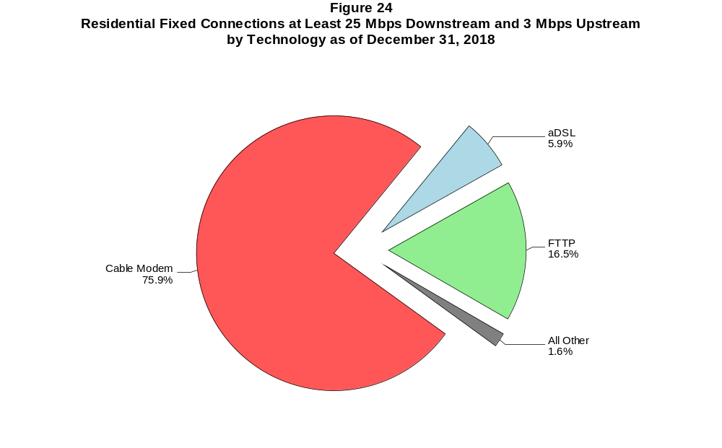

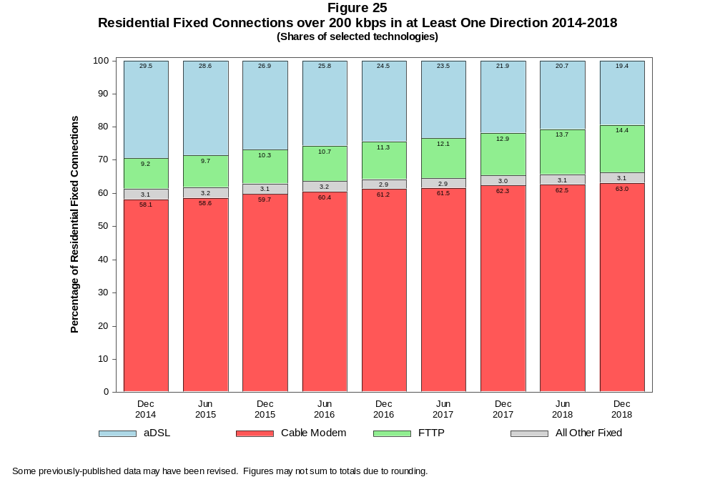

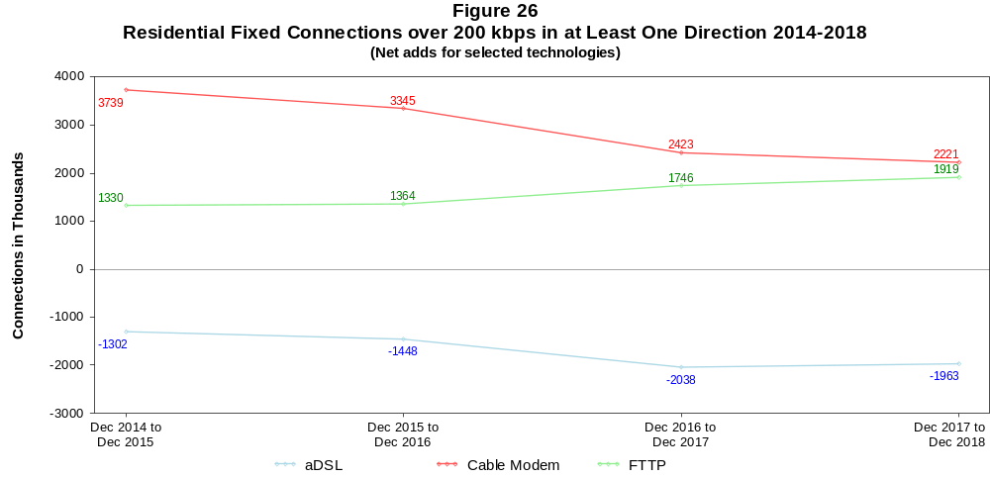

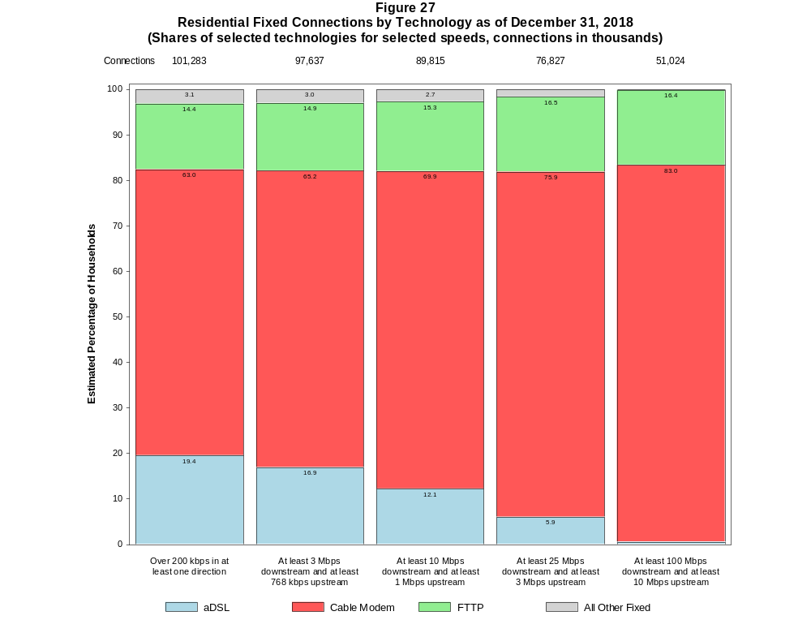

Figure 28
Fixed Connections by Downstream Speed Tier and Technology as of December 31, 2018
(In thousands)

 | Downstream Speed
Technology | Less than  1.5 Mbps | At least 1.5 Mbps  and less than  3 Mbps | At least 3 Mbps  and less than  10 Mbps | At least 10 Mbps  and less than  25 Mbps | At least 25 Mbps  and less than  100 Mbps | At least 100 Mbps | Total
aDSL | 544 | 1,130 | 6,779 | 8,010 | 5,189 | 281 | 21,932
sDSL | 4 | 5 | 5 | 3 | * | * | 20
Other Wireline¹ | 27 | 186 | 85 | 67 | 36 | 199 | 600
Cable Modem | 37 | 56 | 1,044 | 3,991 | 13,102 | 50,625 | 68,857
FTTP | 40 | 34 | 564 | 1,543 | 4,882 | 8,958 | 16,021
Satellite | 179 | 20 | 95 | 683 | * | * | 1,971
Fixed Wireless | 45 | 92 | 579 | 477 | 202 | 70 | 1,465
Total | 877 | 1,522 | 9,151 | 14,774 | 24,404 | 60,137 | 110,866

Percentages

aDSL | 0.5 | 1.0 | 6.1 | 7.2 | 4.7 | 0.3 | 19.8
sDSL | 0.0 | 0.0 | 0.0 | 0.0 | * | * | 0.0
Other Wireline¹ | 0.0 | 0.2 | 0.1 | 0.1 | 0.0 | 0.2 | 0.5
Cable Modem | 0.0 | 0.1 | 0.9 | 3.6 | 11.8 | 45.7 | 62.1
FTTP | 0.0 | 0.0 | 0.5 | 1.4 | 4.4 | 8.1 | 14.5
Satellite | 0.2 | 0.0 | 0.1 | 0.6 | * | * | 1.8
Fixed Wireless | 0.0 | 0.1 | 0.5 | 0.4 | 0.2 | 0.1 | 1.3
Total | 0.8 | 1.4 | 8.3 | 13.3 | 22.0 | 54.2 | 100.0

¹ Power Line and Other are summarized with Other Wireline to maintain firm confidentiality. See Technical Notes at the end of the report for a description of Form 477 technology categories
and other reporting requirements.
# = Rounds to Zero.
* = Data withheld to maintain firm confidentiality.
Note: Figures may not sum to totals due to rounding.
Source: FCC Form 477.

Figure 29
Residential Fixed Connections by Downstream Speed Tier and Technology as of December 31, 2018
(In thousands)

 | Downstream Speed
Technology | Less than  1.5 Mbps | At least 1.5 Mbps  and less than  3 Mbps | At least 3 Mbps  and less than  10 Mbps | At least 10 Mbps  and less than  25 Mbps | At least 25 Mbps  and less than  100 Mbps | At least 100 Mbps | Total
aDSL | 485 | 934 | 5,859 | 7,251 | 4,902 | 260 | 19,691
sDSL | 2 | # | # | # | * | * | 4
Other Wireline¹ | 1 | 3 | 5 | 7 | 12 | 46 | 74
Cable Modem | 31 | 30 | 915 | 3,639 | 10,544 | 48,629 | 63,788
FTTP | 31 | 27 | 517 | 1,321 | 4,349 | 8,376 | 14,621
Satellite | 34 | 6 | 91 | 679 | * | * | 1,787
Fixed Wireless | 40 | 83 | 528 | 428 | 179 | 60 | 1,318
Total | 624 | 1,083 | 7,916 | 13,325 | 20,961 | 57,374 | 101,283

Percentages

aDSL | 0.5 | 0.9 | 5.8 | 7.2 | 4.8 | 0.3 | 19.4
sDSL | 0.0 | 0.0 | 0.0 | 0.0 | * | * | 0.0
Other Wireline¹ | 0.0 | 0.0 | 0.0 | 0.0 | 0.0 | 0.0 | 0.1
Cable Modem | 0.0 | 0.0 | 0.9 | 3.6 | 10.4 | 48.0 | 63.0
FTTP | 0.0 | 0.0 | 0.5 | 1.3 | 4.3 | 8.3 | 14.4
Satellite | 0.0 | 0.0 | 0.1 | 0.7 | * | * | 1.8
Fixed Wireless | 0.0 | 0.1 | 0.5 | 0.4 | 0.2 | 0.1 | 1.3
Total | 0.6 | 1.1 | 7.8 | 13.2 | 20.7 | 56.6 | 100.0

¹ Power Line and Other are summarized with Other Wireline to maintain firm confidentiality. See Technical Notes at the end of the report for a description of Form 477 technology categories
and other reporting requirements.
# = Rounds to Zero.
* = Data withheld to maintain firm confidentiality.
Note: Figures may not sum to totals due to rounding.
Source: FCC Form 477.

Figure 30
Nationwide Number of Providers of Connections over 200 kbps in at Least One Direction
by Technology 2014-2018

 | 2014 | 2015 |  | 2016 |  | 2017 |  | 2018
Technology | Dec | Jun | Dec | Jun | Dec | Jun | Dec | Jun | Dec
aDSL | 793 | 792 | 778 | 769 | 774 | 769 | 743 | 738 | 719
sDSL | 187 | 177 | 180 | 171 | 160 | 161 | 150 | 136 | 125
Other Wireline¹ | 245 | 240 | 250 | 244 | 236 | 243 | 235 | 249 | 239
Cable Modem | 402 | 393 | 392 | 388 | 385 | 384 | 383 | 371 | 374
FTTP | 910 | 931 | 990 | 1,017 | 1,067 | 1,103 | 1,148 | 1,176 | 1,243
Satellite | 14 | 10 | 10 | 6 | 6 | 5 | 6 | 6 | 6
Fixed Wireless | 922 | 948 | 982 | 1,026 | 1,070 | 1,094 | 1,157 | 1,176 | 1,209
Mobile Wireless | 98 | 100 | 96 | 99 | 98 | 98 | 83 | 73 | 71
Power Line and Other¹ | - | - | - | - | - | - | - | - | -
Total | 1,872 | 1,881 | 1,917 | 1,956 | 2,000 | 2,030 | 2,087 | 2,113 | 2,165

¹ For this Figure, the categories Power Line and All Other were combined with Other Wireline.
Multiple Form 477 filers within a holding company structure count as one provider. * = 1-3 providers.
Some previously published data may have been revised.

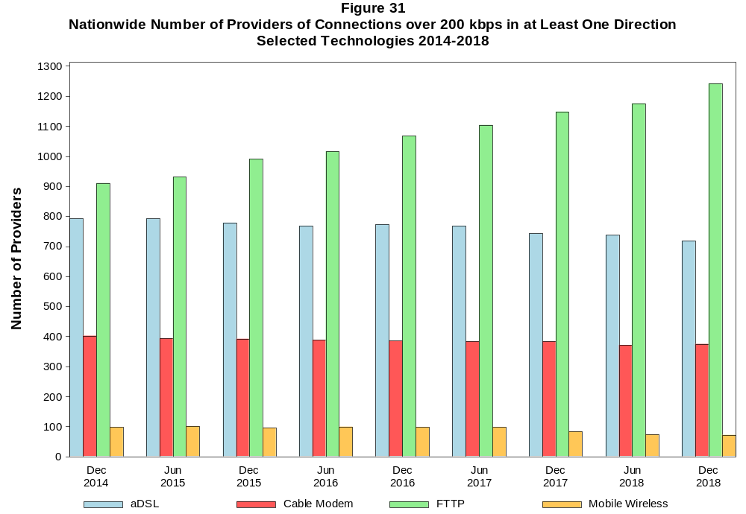

Figure 32
Residential Fixed Connections and Households by State as of December 31, 2018
(Connections and households, in thousands)

 |  | At least 200 kbps in  at least One Direction |  | At least 10 Mbps Down  and 1 Mbps Up |  | At least 25 Mbps Down  and 3 Mbps Up |  | At least 100 Mbps Down  and 10 Mbps Up
State | Households | Connections | Subscribership  Ratio | Connections | Subscribership  Ratio | Connections | Subscribership  Ratio | Connections | Subscribership  Ratio
Alabama | 1,860 | 1,381 | 0.74 | 1,150 | 0.62 | 912 | 0.49 | 647 | 0.35
Alaska | 253 | 201 | 0.79 | 169 | 0.67 | 125 | 0.49 | * | *
American Samoa | 10 | * | * | * | * | * | * | 0 | 0.00
Arizona | 2,524 | 2,201 | 0.87 | 1,873 | 0.74 | 1,625 | 0.64 | 1,070 | 0.42
Arkansas | 1,152 | 787 | 0.68 | 619 | 0.54 | 429 | 0.37 | 205 | 0.18
California | 12,965 | 11,427 | 0.88 | 10,450 | 0.81 | 9,028 | 0.70 | 5,717 | 0.44
Colorado | 2,113 | 1,940 | 0.92 | 1,635 | 0.77 | 1,487 | 0.70 | 643 | 0.30
Connecticut | 1,367 | 1,218 | 0.89 | 1,137 | 0.83 | 947 | 0.69 | 625 | 0.46
Delaware | 358 | 344 | 0.96 | 331 | 0.93 | 319 | 0.89 | 171 | 0.48
District of Columbia | 281 | 253 | 0.90 | 241 | 0.86 | 228 | 0.81 | 144 | 0.51
Florida | 7,622 | 7,229 | 0.95 | 6,688 | 0.88 | 5,724 | 0.75 | 4,257 | 0.56
Georgia | 3,709 | 3,124 | 0.84 | 2,756 | 0.74 | 2,203 | 0.59 | 1,605 | 0.43
Guam | 42 | * | * | * | * | * | * | * | *
Hawaii | 457 | 429 | 0.94 | 409 | 0.89 | * | * | * | *
Idaho | 618 | 507 | 0.82 | 349 | 0.56 | 273 | 0.44 | 73 | 0.12
Illinois | 4,830 | 3,918 | 0.81 | 3,516 | 0.73 | 2,799 | 0.58 | 2,021 | 0.42
Indiana | 2,554 | 1,992 | 0.78 | 1,706 | 0.67 | 1,338 | 0.52 | 924 | 0.36
Iowa | 1,257 | 959 | 0.76 | 734 | 0.58 | 602 | 0.48 | 269 | 0.21
Kansas | 1,125 | 900 | 0.80 | 765 | 0.68 | 590 | 0.52 | 391 | 0.35
Kentucky | 1,729 | 1,312 | 0.76 | 1,083 | 0.63 | 831 | 0.48 | 599 | 0.35
Louisiana | 1,736 | 1,302 | 0.75 | 1,133 | 0.65 | 889 | 0.51 | 599 | 0.35
Maine | 557 | 498 | 0.89 | 395 | 0.71 | 311 | 0.56 | 229 | 0.41
Maryland | 2,193 | 1,964 | 0.90 | 1,881 | 0.86 | 1,758 | 0.80 | 1,006 | 0.46
Massachusetts | 2,602 | 2,389 | 0.92 | 2,277 | 0.88 | 2,196 | 0.84 | 1,277 | 0.49
Michigan | 3,910 | 3,104 | 0.79 | 2,769 | 0.71 | 2,291 | 0.59 | 1,729 | 0.44
Minnesota | 2,168 | 1,763 | 0.81 | 1,449 | 0.67 | 1,261 | 0.58 | 656 | 0.30
Mississippi | 1,106 | 713 | 0.64 | 562 | 0.51 | 367 | 0.33 | 170 | 0.15
Missouri | 2,396 | 1,846 | 0.77 | 1,506 | 0.63 | 1,200 | 0.50 | 883 | 0.37
Montana | 423 | 342 | 0.81 | 264 | 0.62 | 216 | 0.51 | * | *
Nebraska | 754 | 590 | 0.78 | 496 | 0.66 | 404 | 0.54 | 304 | 0.40

Figure 32 - Continued
Residential Fixed Connections and Households by State as of December 31, 2018
(Connections and households, in thousands)

 |  | At least 200 kbps in  at least One Direction |  | At least 10 Mbps Down  and 1 Mbps Up |  | At least 25 Mbps Down  and 3 Mbps Up |  | At least 100 Mbps Down  and 10 Mbps Up
State | Households | Connections | Subscribership  Ratio | Connections | Subscribership  Ratio | Connections | Subscribership  Ratio | Connections | Subscribership  Ratio
Nevada | 1,076 | 949 | 0.88 | 867 | 0.81 | 740 | 0.69 | 590 | 0.55
New Hampshire | 528 | 502 | 0.95 | 448 | 0.85 | 413 | 0.78 | 204 | 0.39
New Jersey | 3,213 | 3,022 | 0.94 | 2,915 | 0.91 | 2,824 | 0.88 | 1,987 | 0.62
New Mexico | 776 | 581 | 0.75 | 412 | 0.53 | 338 | 0.44 | 109 | 0.14
New York | 7,317 | 6,313 | 0.86 | 6,005 | 0.82 | 5,623 | 0.77 | 4,686 | 0.64
North Carolina | 3,919 | 3,271 | 0.83 | 2,783 | 0.71 | 2,460 | 0.63 | 1,972 | 0.50
North Dakota | 315 | 257 | 0.82 | 238 | 0.76 | 213 | 0.68 | 159 | 0.50
Northern Mariana Isl | 16 | * | * | * | * | * | * | 0 | 0.00
Ohio | 4,654 | 3,719 | 0.80 | 3,249 | 0.70 | 2,572 | 0.55 | 1,780 | 0.38
Oklahoma | 1,475 | 1,072 | 0.73 | 871 | 0.59 | 661 | 0.45 | 400 | 0.27
Oregon | 1,592 | 1,349 | 0.85 | 1,155 | 0.73 | 1,031 | 0.65 | 493 | 0.31
Pennsylvania | 5,025 | 4,170 | 0.83 | 3,746 | 0.75 | 3,380 | 0.67 | 1,831 | 0.36
Puerto Rico | 1,205 | 494 | 0.41 | 249 | 0.21 | 161 | 0.13 | * | *
Rhode Island | 411 | 368 | 0.89 | 363 | 0.88 | 344 | 0.84 | * | *
South Carolina | 1,895 | 1,573 | 0.83 | 1,392 | 0.73 | 1,096 | 0.58 | 813 | 0.43
South Dakota | 342 | 269 | 0.79 | 248 | 0.73 | 222 | 0.65 | 150 | 0.44
Tennessee | 2,567 | 2,000 | 0.78 | 1,781 | 0.69 | 1,457 | 0.57 | 1,127 | 0.44
Texas | 9,553 | 7,860 | 0.82 | 7,060 | 0.74 | 5,849 | 0.61 | 3,650 | 0.38
Utah | 958 | 860 | 0.90 | 727 | 0.76 | 632 | 0.66 | 268 | 0.28
Vermont | 260 | 241 | 0.93 | 181 | 0.70 | 150 | 0.58 | 72 | 0.28
Virgin Islands | 43 | 27 | 0.61 | * | * | 7 | 0.15 | * | *
Virginia | 3,128 | 2,637 | 0.84 | 2,402 | 0.77 | 2,215 | 0.71 | 1,446 | 0.46
Washington | 2,800 | 2,484 | 0.89 | 2,168 | 0.77 | 1,969 | 0.70 | 937 | 0.33
West Virginia | 735 | 541 | 0.74 | 422 | 0.57 | 341 | 0.46 | 173 | 0.24
Wisconsin | 2,343 | 1,861 | 0.79 | 1,589 | 0.68 | 1,256 | 0.54 | 967 | 0.41
Wyoming | 231 | 186 | 0.81 | 149 | 0.65 | 130 | 0.56 | * | *
Total | 121,046 | 101,283 | 0.84 | 89,815 | 0.74 | 76,827 | 0.63 | 51,024 | 0.42

# = Rounds to Zero; * = Data withheld to maintain firm confidentiality.
Note: Figures may not sum to totals due to rounding.
Sources: FCC Form 477 (Connections); 2014-2018 ACS 5-year estimates; Census 2010.

Figure 33
Connections by Type of End User by State as of December 31, 2018
(Connections over 200 kbps in at least one direction, in thousands)

 | Connections |  | Percentages
State | Residential | Business | Residential | Business | Total
Alabama | 5,170 | 1,196 | 81.2 | 18.8 | 6,366
Alaska | 821 | 123 | 87.0 | 13.0 | 944
American Samoa | * | * | * | * | *
Arizona | 7,377 | 1,347 | 84.6 | 15.4 | 8,724
Arkansas | 2,870 | 782 | 78.6 | 21.4 | 3,651
California | 46,733 | 7,676 | 85.9 | 14.1 | 54,409
Colorado | 6,290 | 1,243 | 83.5 | 16.5 | 7,534
Connecticut | 4,081 | 900 | 81.9 | 18.1 | 4,981
Delaware | 1,080 | 209 | 83.8 | 16.2 | 1,289
District of Columbia | 982 | 524 | 65.2 | 34.8 | 1,506
Florida | 24,716 | 4,484 | 84.6 | 15.4 | 29,200
Georgia | 11,442 | 2,602 | 81.5 | 18.5 | 14,044
Guam | 182 | 53 | 77.5 | 22.5 | 235
Hawaii | 1,701 | 283 | 85.7 | 14.3 | 1,984
Idaho | 1,763 | 360 | 83.0 | 17.0 | 2,123
Illinois | 14,289 | 2,979 | 82.7 | 17.3 | 17,269
Indiana | 6,870 | 1,466 | 82.4 | 17.6 | 8,337
Iowa | 3,247 | 753 | 81.2 | 18.8 | 4,000
Kansas | 5,069 | 706 | 87.8 | 12.2 | 5,775
Kentucky | 4,837 | 833 | 85.3 | 14.7 | 5,670
Louisiana | 5,189 | 932 | 84.8 | 15.2 | 6,121
Maine | 1,409 | 408 | 77.5 | 22.5 | 1,817
Maryland | 7,141 | 1,259 | 85.0 | 15.0 | 8,400
Massachusetts | 8,372 | 1,619 | 83.8 | 16.2 | 9,991
Michigan | 10,814 | 2,438 | 81.6 | 18.4 | 13,252
Minnesota | 6,070 | 1,350 | 81.8 | 18.2 | 7,421
Mississippi | 2,993 | 559 | 84.3 | 15.7 | 3,552
Missouri | 6,452 | 1,373 | 82.5 | 17.5 | 7,825
Montana | 1,056 | 284 | 78.8 | 21.2 | 1,340
Nebraska | 1,890 | 544 | 77.6 | 22.4 | 2,434
Nevada | 3,387 | 566 | 85.7 | 14.3 | 3,954
New Hampshire | 1,483 | 362 | 80.4 | 19.6 | 1,845
New Jersey | 10,584 | 2,060 | 83.7 | 16.3 | 12,644
New Mexico | 2,102 | 383 | 84.6 | 15.4 | 2,485
New York | 24,394 | 4,407 | 84.7 | 15.3 | 28,801
North Carolina | 10,646 | 2,448 | 81.3 | 18.7 | 13,094
North Dakota | 806 | 214 | 79.1 | 20.9 | 1,019
Northern Mariana Isl | * | * | * | * | *
Ohio | 12,806 | 2,839 | 81.9 | 18.1 | 15,645
Oklahoma | 4,063 | 760 | 84.2 | 15.8 | 4,823
Oregon | 4,569 | 962 | 82.6 | 17.4 | 5,531
Pennsylvania | 14,198 | 2,940 | 82.8 | 17.2 | 17,138
Puerto Rico | 3,679 | 407 | 90.0 | 10.0 | 4,086
Rhode Island | 1,141 | 233 | 83.1 | 16.9 | 1,374
South Carolina | 5,151 | 1,146 | 81.8 | 18.2 | 6,297
South Dakota | 855 | 236 | 78.4 | 21.6 | 1,091
Tennessee | 7,005 | 1,683 | 80.6 | 19.4 | 8,688
Texas | 31,260 | 5,529 | 85.0 | 15.0 | 36,789
Utah | 3,077 | 644 | 82.7 | 17.3 | 3,722
Vermont | 679 | 191 | 78.1 | 21.9 | 870
Virgin Islands | 124 | 14 | 89.8 | 10.2 | 138
Virginia | 8,678 | 2,171 | 80.0 | 20.0 | 10,850
Washington | 8,503 | 1,625 | 84.0 | 16.0 | 10,128
West Virginia | 1,636 | 309 | 84.1 | 15.9 | 1,945
Wisconsin | 6,015 | 1,327 | 81.9 | 18.1 | 7,342
Wyoming | 624 | 161 | 79.5 | 20.5 | 785
Total | 368,473 | 72,924 | 83.5 | 16.5 | 441,397

# = Rounds to Zero.
* = Data withheld to maintain firm confidentiality.
Figures may not sum to totals due to rounding.
Source: FCC Form 477.

Figure 34
Connections by Technology by State as of December 31, 2018
(Connections over 200 kbps in at least one direction, in thousands)

State | ADSL | SDSL | Other  Wireline¹ | Cable  Modem | Fiber | Satellite | Fixed  Wireless | Mobile  Wireless | Total
Alabama | 460 | # | * | 805 | 174 | * | 6 | 4,853 | 6,366
Alaska | 76 | * | 2 | * | 6 | * | 9 | 707 | 944
American Samoa | 0 | 0 | 0 | * | * | 0 | * | * | *
Arizona | 519 | * | 11 | 1,581 | 174 | * | 43 | 6,359 | 8,724
Arkansas | 334 | # | * | 409 | 60 | * | 8 | 2,785 | 3,651
California | 2,774 | 3 | * | 8,176 | 1,234 | * | 142 | 41,863 | 54,409
Colorado | * | # | 17 | 1,355 | 209 | * | 77 | 5,425 | 7,534
Connecticut | * | * | 3 | 1,029 | 21 | * | # | 3,644 | 4,981
Delaware | * | * | 3 | 236 | * | * | * | 916 | 1,289
District of Columbia | * | * | 6 | * | * | * | * | 1,217 | 1,506
Florida | 1,435 | # | * | 5,305 | 1,002 | * | 18 | 21,317 | 29,200
Georgia | 902 | # | * | 1,933 | 499 | * | 6 | 10,616 | 14,044
Guam | * | 0 | 0 | * | * | 0 | 0 | 193 | 235
Hawaii | * | * | 1 | * | * | * | 2 | 1,522 | 1,984
Idaho | 164 | # | * | 232 | 91 | * | 47 | 1,569 | 2,123
Illinois | 1,090 | 1 | * | 2,815 | 236 | * | 80 | 12,975 | 17,269
Indiana | 579 | # | * | 1,201 | 280 | * | 44 | 6,175 | 8,337
Iowa | 265 | # | * | 489 | 214 | * | 43 | 2,954 | 4,000
Kansas | 230 | # | * | 478 | 208 | * | 40 | 4,796 | 5,775
Kentucky | 390 | * | 4 | 788 | 188 | * | 18 | 4,243 | 5,670
Louisiana | 394 | * | 5 | 829 | 140 | * | 8 | 4,687 | 6,121
Maine | 118 | 1 | * | 398 | 10 | * | 6 | 1,270 | 1,817
Maryland | * | # | 16 | 1,157 | * | * | 5 | 6,270 | 8,400
Massachusetts | * | * | 21 | 1,948 | * | * | 8 | 7,374 | 9,991
Michigan | 774 | 2 | * | 2,332 | 119 | * | 43 | 9,885 | 13,252
Minnesota | 449 | 2 | * | 1,172 | 225 | * | 35 | 5,502 | 7,421
Mississippi | 340 | # | * | 332 | 51 | * | 5 | 2,762 | 3,552
Missouri | 624 | 1 | * | 957 | 298 | * | 44 | 5,819 | 7,825
Montana | 96 | * | 2 | 215 | 32 | * | 24 | 957 | 1,340
Nebraska | 140 | # | * | 391 | 75 | * | 30 | 1,787 | 2,434

Figure 34 - Continued
Connections by Technology by State as of December 31, 2018
(Connections over 200 kbps in at least one direction, in thousands)

State | ADSL | SDSL | Other  Wireline¹ | Cable  Modem | Fiber | Satellite | Fixed  Wireless | Mobile  Wireless | Total
Nevada | 197 | # | 6 | * | 47 | * | 26 | 2,920 | 3,954
New Hampshire | 68 | # | * | 446 | 30 | * | 1 | 1,290 | 1,845
New Jersey | 128 | * | 27 | 2,146 | * | * | # | 9,312 | 12,644
New Mexico | 219 | * | 4 | 322 | 54 | * | 23 | 1,848 | 2,485
New York | 330 | * | 40 | 4,881 | 1,653 | * | 9 | 21,831 | 28,801
North Carolina | 751 | # | * | 2,281 | 426 | * | 8 | 9,544 | 13,094
North Dakota | 32 | 1 | * | 157 | 90 | * | 4 | 733 | 1,019
Northern Mariana Isl | * | 0 | * | * | * | 0 | * | * | *
Ohio | 961 | * | 14 | 2,650 | 311 | * | 48 | 11,610 | 15,645
Oklahoma | 359 | # | * | 598 | 115 | * | 54 | 3,640 | 4,823
Oregon | 228 | # | * | 992 | 183 | * | 28 | 4,057 | 5,531
Pennsylvania | 510 | # | 27 | 2,976 | * | * | 7 | 12,570 | 17,138
Puerto Rico | * | 0 | 11 | * | 8 | * | 19 | 3,436 | 4,086
Rhode Island | * | * | 2 | * | * | * | * | 972 | 1,374
South Carolina | 417 | # | * | 1,049 | 192 | * | 5 | 4,590 | 6,297
South Dakota | 39 | * | # | 177 | 64 | * | 10 | 793 | 1,091
Tennessee | 500 | # | * | 1,226 | 370 | * | 14 | 6,506 | 8,688
Texas | 2,005 | # | * | 4,550 | 1,574 | * | 230 | 28,186 | 36,789
Utah | 155 | * | 6 | 532 | 181 | * | 54 | 2,788 | 3,722
Vermont | 82 | * | 3 | 151 | 26 | * | 4 | 599 | 870
Virgin Islands | * | 0 | * | * | * | * | * | * | 138
Virginia | 265 | # | * | 1,545 | 944 | * | 18 | 7,963 | 10,850
Washington | 400 | # | * | 1,925 | 239 | * | 37 | 7,447 | 10,128
West Virginia | * | * | 1 | 380 | 12 | * | 3 | 1,349 | 1,945
Wisconsin | 586 | * | 11 | * | 148 | * | 32 | 5,312 | 7,342
Wyoming | 47 | # | * | 114 | 13 | * | 26 | 576 | 785
Total | 21,932 | 20 | 600 | 68,857 | 16,021 | 1,971 | 1,465 | 330,531 | 441,397

¹ Power Line and Other are summarized with Other Wireline to maintain firm confidentiality. See Technical Notes at the end of the report for a description of Form 477 technology categories and
other reporting requirements.
# = Rounds to Zero.
* = Data withheld to maintain firm confidentiality.
Figures may not sum to totals due to rounding.
Source: FCC Form 477.

Figure 35
Percentage of Fixed Connections by Downstream Speed by State as of December 31, 2018

 | Over 200 kbps Upstream and
State | % over 200 kbps  Downstream | % at least 3 Mbps  Downstream | % at least 10 Mbps  Downstream | % at least 25 Mbps  Downstream | % at least 100 Mbps  Downstream
Alabama | 99.6 | 96.2 | 84.7 | 67.6 | 46.2
Alaska | 98.8 | 94.1 | 81.9 | 60.4 | 44.1
American Samoa | * | * | * | * | *
Arizona | 99.8 | 98.1 | 92.3 | 73.9 | 51.3
Arkansas | 99.7 | 95.7 | 81.7 | 56.9 | 28.6
California | 99.8 | 98.3 | 90.3 | 77.5 | 55.5
Colorado | 99.8 | 97.4 | 91.8 | 76.7 | 50.4
Connecticut | 99.7 | 99.4 | 92.2 | 77.1 | 61.4
Delaware | 99.9 | 99.0 | 95.2 | 91.8 | 66.2
District of Columbia | 99.9 | 98.5 | 92.8 | 87.5 | 69.8
Florida | 99.8 | 98.6 | 93.9 | 82.2 | 56.6
Georgia | 99.4 | 97.2 | 88.3 | 73.3 | 49.1
Guam | * | * | * | * | *
Hawaii | 99.9 | 99.8 | 93.1 | 86.5 | 61.2
Idaho | 99.7 | 96.5 | 81.2 | 54.7 | 37.6
Illinois | 99.8 | 98.3 | 89.2 | 74.5 | 49.7
Indiana | 99.6 | 97.9 | 86.3 | 69.6 | 44.9
Iowa | 99.8 | 95.9 | 83.4 | 64.5 | 28.5
Kansas | 99.9 | 97.5 | 86.0 | 64.2 | 42.4
Kentucky | 99.4 | 96.3 | 83.1 | 65.3 | 44.9
Louisiana | 99.6 | 96.5 | 87.1 | 68.9 | 45.5
Maine | 99.3 | 93.4 | 77.8 | 61.1 | 47.7
Maryland | 99.9 | 98.9 | 94.6 | 88.8 | 64.9
Massachusetts | 99.9 | 98.9 | 94.4 | 90.9 | 69.9
Michigan | 99.5 | 98.1 | 88.9 | 76.0 | 53.1
Minnesota | 99.8 | 97.4 | 88.4 | 72.0 | 47.0
Mississippi | 99.4 | 94.7 | 79.3 | 55.3 | 30.3
Missouri | 99.7 | 96.6 | 84.7 | 66.0 | 48.4
Montana | 99.8 | 95.1 | 82.8 | 64.2 | 50.5
Nebraska | 99.7 | 97.6 | 87.2 | 69.1 | 50.6

Figure 35 - Continued
Percentage of Fixed Connections by Downstream Speed by State as of December 31, 2018

 | Over 200 kbps Upstream and
State | % over 200 kbps  Downstream | % at least 3 Mbps  Downstream | % at least 10 Mbps  Downstream | % at least 25 Mbps  Downstream | % at least 100 Mbps  Downstream
Nevada | 99.9 | 98.8 | 93.8 | 79.7 | 59.3
New Hampshire | 99.4 | 95.0 | 87.8 | 80.6 | 64.7
New Jersey | 99.8 | 99.0 | 95.8 | 92.7 | 73.8
New Mexico | 99.8 | 95.0 | 82.9 | 59.7 | 32.4
New York | 99.7 | 99.0 | 94.1 | 87.8 | 72.4
North Carolina | 99.4 | 97.5 | 87.7 | 75.1 | 58.8
North Dakota | 99.9 | 98.4 | 93.4 | 82.7 | 61.1
Northern Mariana Isl | * | * | * | * | *
Ohio | 99.9 | 97.9 | 87.5 | 69.3 | 47.8
Oklahoma | 99.8 | 97.5 | 81.4 | 60.7 | 38.7
Oregon | 99.8 | 97.4 | 90.2 | 76.9 | 52.0
Pennsylvania | 99.8 | 98.0 | 90.3 | 82.6 | 57.1
Puerto Rico | 100.0 | 89.0 | 57.3 | 37.5 | 17.7
Rhode Island | 99.7 | 99.0 | 97.8 | 91.8 | 73.2
South Carolina | 99.7 | 97.8 | 88.8 | 71.2 | 51.6
South Dakota | 99.7 | 98.4 | 93.4 | 82.1 | 52.7
Tennessee | 99.6 | 97.6 | 89.1 | 74.8 | 54.0
Texas | 99.8 | 98.3 | 89.7 | 73.9 | 50.9
Utah | 99.9 | 98.4 | 90.8 | 74.2 | 45.3
Vermont | 97.9 | 89.0 | 74.3 | 62.0 | 44.2
Virgin Islands | 99.9 | 99.0 | 62.8 | * | *
Virginia | 99.5 | 97.9 | 91.0 | 82.9 | 61.3
Washington | 99.7 | 97.7 | 91.3 | 79.2 | 57.2
West Virginia | 98.6 | 97.5 | 76.9 | 62.3 | 42.4
Wisconsin | 99.4 | 96.8 | 86.7 | 67.6 | 50.5
Wyoming | 99.8 | 95.6 | 84.6 | 71.6 | 45.9
Total | 99.7 | 97.8 | 89.6 | 76.3 | 54.2

Figure 36
Providers of Connections by Technology by State as of December 31, 2018
(Connections over 200 kbps in at least one direction, in thousands)

State | ADSL | SDSL | Other  Wireline¹ | Cable  Modem | Fiber | Satellite | Fixed  Wireless | Mobile  Wireless | Total
Alabama | 25 | 4 | * | 19 | 41 | * | 21 | 7 | 82
Alaska | 14 | * | 11 | * | 13 | * | 14 | 9 | 36
American Samoa | 0 | 0 | 0 | * | * | 0 | * | * | *
Arizona | 23 | * | 24 | 14 | 41 | * | 46 | 6 | 102
Arkansas | 24 | 4 | * | 21 | 43 | * | 22 | 5 | 84
California | 34 | 11 | * | 31 | 83 | * | 127 | 5 | 211
Colorado | * | 6 | 25 | 15 | 62 | * | 64 | 9 | 137
Connecticut | * | * | 12 | 8 | 21 | * | 4 | 4 | 34
Delaware | * | * | 9 | 6 | * | * | * | 4 | 25
District of Columbia | * | * | 14 | * | * | * | * | 4 | 39
Florida | 22 | 7 | * | 22 | 70 | * | 32 | 6 | 112
Georgia | 27 | 4 | * | 32 | 82 | * | 23 | 5 | 123
Guam | * | 0 | 0 | * | * | 0 | 0 | 4 | 4
Hawaii | * | * | 11 | * | * | * | 5 | 5 | 25
Idaho | 23 | 5 | * | 20 | 40 | * | 40 | 9 | 76
Illinois | 53 | 7 | * | 20 | 101 | * | 91 | 6 | 194
Indiana | 35 | 4 | * | 13 | 72 | * | 60 | 5 | 116
Iowa | 88 | 16 | * | 40 | 166 | * | 87 | 8 | 230
Kansas | 25 | 9 | * | 26 | 65 | * | 51 | 9 | 112
Kentucky | 18 | * | 12 | 29 | 48 | * | 31 | 8 | 102
Louisiana | 17 | * | 19 | 20 | 40 | * | 21 | 6 | 75
Maine | 11 | 5 | * | 9 | 18 | * | 10 | 5 | 37
Maryland | * | 5 | 19 | 15 | * | * | 20 | 5 | 69
Massachusetts | * | * | 15 | 11 | * | * | 22 | 5 | 68
Michigan | 33 | 5 | * | 25 | 69 | * | 47 | 6 | 125
Minnesota | 44 | 8 | * | 21 | 81 | * | 51 | 5 | 129
Mississippi | 19 | 4 | * | 14 | 30 | * | 14 | 6 | 60
Missouri | 35 | 8 | * | 19 | 67 | * | 71 | 7 | 144
Montana | 22 | * | 14 | 8 | 33 | * | 31 | 7 | 63
Nebraska | 31 | 4 | * | 18 | 56 | * | 46 | 7 | 104

Figure 36 - Continued
Providers of Connections by Technology by State as of December 31, 2018
(Connections over 200 kbps in at least one direction, in thousands)

State | ADSL | SDSL | Other  Wireline¹ | Cable  Modem | Fiber | Satellite | Fixed  Wireless | Mobile  Wireless | Total
Nevada | 18 | 7 | 18 | * | 33 | * | 23 | 5 | 68
New Hampshire | 8 | 4 | * | 5 | 20 | * | 7 | 5 | 36
New Jersey | 10 | * | 27 | 10 | * | * | 10 | 4 | 62
New Mexico | 21 | * | 16 | 11 | 32 | * | 35 | 7 | 73
New York | 32 | * | 33 | 22 | 73 | * | 33 | 6 | 125
North Carolina | 23 | 5 | * | 26 | 58 | * | 23 | 6 | 99
North Dakota | 21 | 7 | * | 9 | 31 | * | 12 | 6 | 47
Northern Mariana Isl | * | 0 | * | * | * | 0 | * | * | *
Ohio | 32 | * | 30 | 32 | 67 | * | 61 | 4 | 149
Oklahoma | 37 | 6 | * | 13 | 55 | * | 49 | 12 | 113
Oregon | 38 | 8 | * | 17 | 61 | * | 46 | 6 | 104
Pennsylvania | 22 | 5 | 25 | 25 | * | * | 25 | 8 | 107
Puerto Rico | * | 0 | 5 | * | 8 | * | 8 | 5 | 19
Rhode Island | * | * | 8 | * | * | * | * | 4 | 24
South Carolina | 20 | 4 | * | 17 | 33 | * | 15 | 6 | 56
South Dakota | 22 | * | 13 | 9 | 32 | * | 20 | 8 | 71
Tennessee | 23 | 4 | * | 22 | 69 | * | 35 | 7 | 116
Texas | 65 | 14 | * | 33 | 131 | * | 153 | 10 | 260
Utah | 19 | * | 15 | 13 | 29 | * | 34 | 9 | 72
Vermont | 8 | * | 7 | 6 | 18 | * | 5 | 6 | 32
Virgin Islands | * | 0 | * | * | * | * | * | * | 7
Virginia | 24 | 6 | * | 20 | 68 | * | 39 | 6 | 110
Washington | 27 | 6 | * | 24 | 62 | * | 55 | 6 | 117
West Virginia | * | * | 11 | 17 | 23 | * | 16 | 6 | 59
Wisconsin | 42 | * | 22 | * | 70 | * | 41 | 6 | 116
Wyoming | 15 | 4 | * | 7 | 20 | * | 24 | 8 | 49
Total | 719 | 125 | 239 | 374 | 1,243 | 6 | 1,209 | 71 | 2,165

¹ Power Line and Other are summarized with Other Wireline. See Technical Notes at the end of the report for a description of Form 477 technology categories and other reporting requirements.
# = Rounds to Zero.
* = Data withheld to maintain firm confidentiality.
Figures may not sum to totals due to rounding.
Source: FCC Form 477.
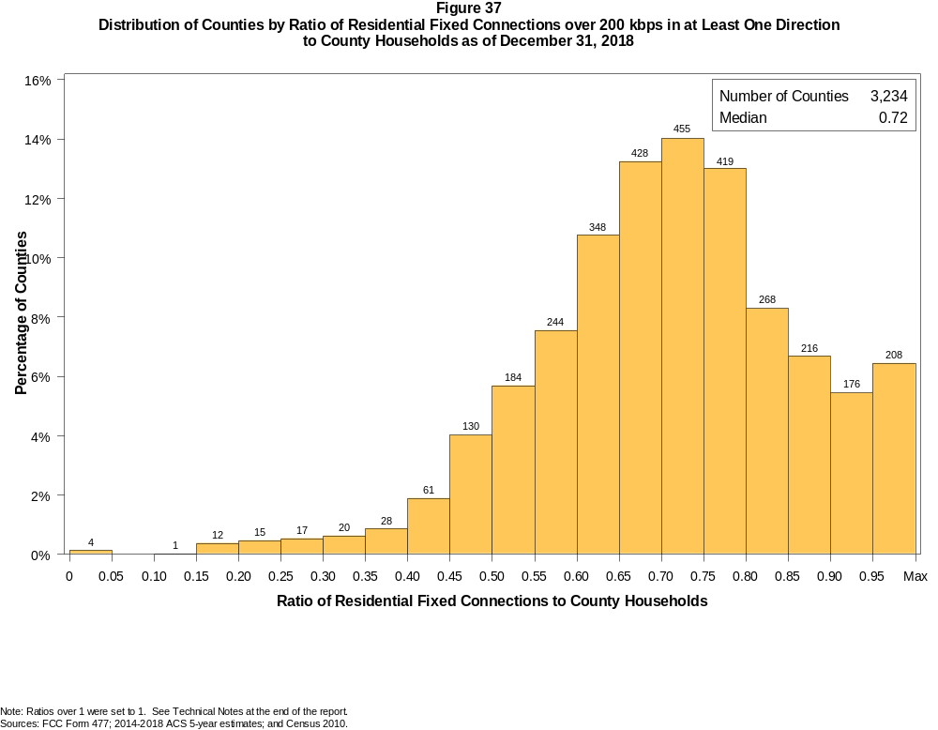

Figure 38
Distribution of Counties by Ratio of Residential Fixed Connections over 200 kbps in at Least One Direction
to County Households by Technology as of December 31, 2018

 | Ratio of Residential Fixed Connections to County Households
Technology | Zero | Greater than 0 and no more than 5% | Greater than 5 and no more than 10% | Greater than 10 and no more than 20% | Greater than 20 and no more than 30% | Greater than 30 and no more than 40% | Greater than 40 and no more than 50% | Greater than 50 and no more than 60% | Greater than 60 and no more than 80% | Greater than 80 and no more than 100% | 100% or more
aDSL | 1.5 | 6.9 | 8.8 | 29.1 | 27.1 | 15.6 | 6.9 | 2.5 | 1.3 | 0.3 | 0.1
sDSL | 94.6 | 5.4 | 0.0 | 0.0 | 0.0 | 0.0 | 0.0 | 0.0 | 0.0 | 0.0 | 0.0
Other Wireline | 92.7 | 7.1 | 0.2 | 0.0 | 0.0 | 0.0 | 0.0 | 0.0 | 0.0 | 0.0 | 0.0
Cable Modem | 12.0 | 7.1 | 5.9 | 13.7 | 13.0 | 12.3 | 12.4 | 11.5 | 10.1 | 1.5 | 0.4
FTTP | 20.2 | 43.0 | 10.4 | 10.5 | 5.9 | 3.1 | 2.5 | 1.8 | 2.3 | 0.3 | 0.0
Satellite | 0.4 | 64.5 | 22.8 | 11.0 | 0.9 | 0.4 | 0.0 | 0.0 | 0.0 | 0.0 | 0.0
Fixed Wireless | 18.1 | 58.4 | 12.0 | 8.1 | 2.1 | 1.0 | 0.2 | 0.1 | 0.1 | 0.0 | 0.1
Total | 0.1 | 0.0 | 0.0 | 0.4 | 1.0 | 1.5 | 5.9 | 13.2 | 51.0 | 23.0 | 3.8

¹ Power Line and Other are summarized with Other Wireline. See Technical Notes at the end of the report for a description of Form 477 technology categories and other reporting requirements.
Note: Figures may not sum to totals due to rounding.
Sources: FCC Form 477; 2014-2018 ACS 5-year estimates; and Census 2010.

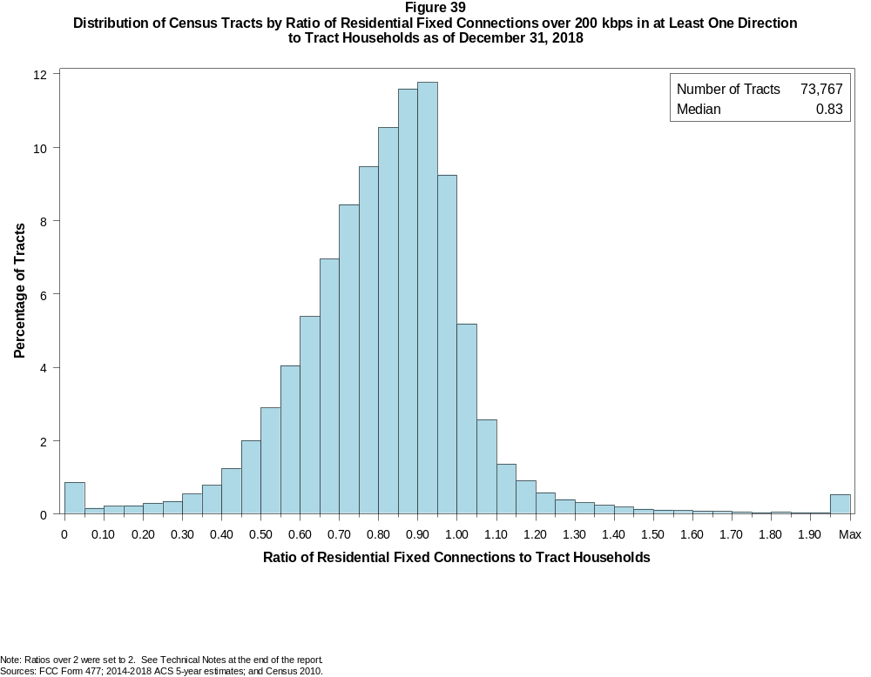

Figure 40
Distribution of Census Tracts by Ratio of Residential Fixed Connections over 200 kbps in at Least One Direction
to Tract Households by Technology as of December 31, 2018

 | Ratio of Residential Fixed Connections to Tract Households
Technology | Zero | Greater than 0 and no more than 5% | Greater than 5 and no more than 10% | Greater than 10 and no more than 20% | Greater than 20 and no more than 30% | Greater than 30 and no more than 40% | Greater than 40 and no more than 50% | Greater than 50 and no more than 60% | Greater than 60 and no more than 80% | Greater than 80 and no more than 100% | 100% or more
aDSL | 3.1 | 23.6 | 14.8 | 25.3 | 17.6 | 9.1 | 3.7 | 1.5 | 0.9 | 0.2 | 0.2
sDSL | 99.4 | 0.5 | 0.0 | 0.0 | 0.0 | 0.0 | 0.0 | 0.0 | 0.0 | 0.0 | 0.0
Other Wireline | 98.8 | 1.0 | 0.1 | 0.1 | 0.0 | 0.0 | 0.0 | 0.0 | 0.0 | 0.0 | 0.0
Cable Modem | 5.2 | 2.6 | 1.6 | 3.6 | 5.7 | 10.7 | 16.1 | 19.1 | 25.7 | 7.8 | 1.9
FTTP | 37.2 | 21.6 | 7.9 | 10.9 | 7.2 | 5.5 | 4.1 | 2.7 | 2.4 | 0.4 | 0.2
Satellite | 23.8 | 65.9 | 5.6 | 3.7 | 0.8 | 0.2 | 0.1 | 0.0 | 0.0 | 0.0 | 0.0
Fixed Wireless | 71.3 | 22.1 | 2.8 | 2.3 | 0.8 | 0.3 | 0.1 | 0.1 | 0.0 | 0.0 | 0.0
Total | 0.8 | 0.1 | 0.2 | 0.5 | 0.6 | 1.3 | 3.3 | 6.9 | 30.3 | 43.2 | 12.9

¹ Power Line and Other are summarized with Other Wireline. See Technical Notes at the end of the report for a description of Form 477 technology categories and other reporting requirements.
Note: Figures may not sum to totals due to rounding.
Sources: FCC Form 477; 2014-2018 ACS 5-year estimates; and Census 2010.

Figure 41
Percentage of Developed Census Blocks with Residential Fixed Service by Technology as of December 31, 2018
(Internet Access Service over 200 kbps in at least one direction)

 | Number of Providers
Technology | Zero | One | Two | Three | Four | Five | Six | Seven or More
aDSL | 22.4 | 74.9 | 2.7 | 0.1 | 0.0 | 0.0 | 0.0 | 0.0
sDSL | 99.5 | 0.5 | 0.0 | 0.0 | 0.0 | 0.0 | 0.0 | 0.0
Other Wireline¹ | 99.0 | 1.0 | 0.0 | 0.0 | 0.0 | 0.0 | 0.0 | 0.0
Cable Modem | 80.3 | 19.1 | 0.6 | 0.0 | 0.0 | 0.0 | 0.0 | 0.0
FTTP | 74.1 | 24.8 | 1.1 | 0.1 | 0.0 | 0.0 | 0.0 | 0.0
Satellite | 0.0 | 0.1 | 0.9 | 98.9 | 0.0 | 0.0 | 0.0 | 0.0
Fixed Wireless | 58.6 | 26.8 | 10.8 | 3.3 | 0.5 | 0.0 | 0.0 | 0.0
aDSL and/or Cable Modem and/or FTTP | 14.2 | 62.0 | 21.4 | 2.3 | 0.1 | 0.0 | 0.0 | 0.0
Any Technology | 0.0 | 0.1 | 0.1 | 5.1 | 17.6 | 43.8 | 22.6 | 10.9

¹ Power Line and Other are summarized with Other Wireline. See Technical Notes at the end of the report for a description of Form 477 technology categories and other reporting requirements.
Note: Figures may not sum to totals due to rounding. The number of providers in a census block does not necessarily reflect the number of choices available to a particular household, and does not
purport to measure competition. Providers may list a census block on Form 477 if service can be provided to at least one location in the block. Developed census blocks are those with housing units
based on the 2010 census.
Sources: FCC Form 477 and Census 2010.

Figure 42
Distribution of Counties by Ratio of Residential Fixed Connections to County Households by State as of December 31, 2018
(Connections over 200 kbps in at least one direction)

 |  | Ratio of Residential Fixed Connections over 200 kbps in at Least One Direction to County Households
State | Counties | Zero | Greater than 0 and no more than 5% | Greater than 5 and no more than 10% | Greater than 10 and no more than 20% | Greater than 20 and no more than 30% | Greater than 30 and no more than 40% | Greater than 40 and no more than 50% | Greater than 50 and no more than 60% | Greater than 60 and no more than 80% | Greater than 80 and no more than 100% | 100% or more
Alabama | 67 | 0 | 0 | 0 | 0 | 0 | 0 | 15 | 13 | 31 | 8 | 0
Alaska | 29 | 0 | 0 | 0 | 1 | 1 | 1 | 3 | 1 | 11 | 8 | 3
American Samoa | 5 | 2 | 0 | 0 | 0 | 2 | 0 | 1 | 0 | 0 | 0 | 0
Arizona | 15 | 0 | 0 | 0 | 0 | 0 | 0 | 1 | 1 | 6 | 7 | 0
Arkansas | 75 | 0 | 0 | 0 | 0 | 0 | 2 | 18 | 29 | 23 | 3 | 0
California | 58 | 0 | 0 | 0 | 0 | 0 | 0 | 0 | 0 | 16 | 39 | 3
Colorado | 64 | 0 | 0 | 0 | 0 | 0 | 1 | 0 | 7 | 19 | 22 | 15
Connecticut | 8 | 0 | 0 | 0 | 0 | 0 | 0 | 0 | 0 | 0 | 8 | 0
Delaware | 3 | 0 | 0 | 0 | 0 | 0 | 0 | 0 | 0 | 0 | 2 | 1
District of Columbia | 1 | 0 | 0 | 0 | 0 | 0 | 0 | 0 | 0 | 0 | 1 | 0
Florida | 67 | 0 | 0 | 0 | 0 | 0 | 0 | 0 | 5 | 19 | 28 | 15
Georgia | 159 | 0 | 0 | 0 | 1 | 2 | 6 | 17 | 29 | 63 | 32 | 9
Guam | 1 | 0 | 0 | 0 | 0 | 0 | 0 | 0 | 0 | 1 | 0 | 0
Hawaii | 5 | 0 | 1 | 0 | 0 | 0 | 0 | 0 | 0 | 1 | 1 | 2
Idaho | 44 | 0 | 0 | 0 | 0 | 0 | 0 | 2 | 2 | 26 | 10 | 4
Illinois | 102 | 0 | 0 | 0 | 0 | 0 | 1 | 3 | 19 | 63 | 16 | 0
Indiana | 92 | 0 | 0 | 0 | 0 | 0 | 0 | 0 | 15 | 62 | 15 | 0
Iowa | 99 | 0 | 0 | 0 | 0 | 0 | 0 | 0 | 6 | 86 | 6 | 1
Kansas | 105 | 0 | 0 | 0 | 0 | 0 | 0 | 2 | 12 | 73 | 18 | 0
Kentucky | 120 | 0 | 0 | 0 | 0 | 1 | 1 | 7 | 12 | 84 | 15 | 0
Louisiana | 64 | 0 | 0 | 0 | 0 | 0 | 2 | 11 | 14 | 28 | 9 | 0
Maine | 16 | 0 | 0 | 0 | 0 | 0 | 0 | 0 | 0 | 3 | 11 | 2
Maryland | 24 | 0 | 0 | 0 | 0 | 0 | 0 | 0 | 0 | 7 | 16 | 1
Massachusetts | 14 | 0 | 0 | 0 | 0 | 0 | 0 | 0 | 0 | 0 | 11 | 3
Michigan | 83 | 0 | 0 | 0 | 0 | 0 | 0 | 1 | 8 | 55 | 16 | 3
Minnesota | 87 | 0 | 0 | 0 | 0 | 0 | 0 | 0 | 3 | 62 | 21 | 1
Mississippi | 82 | 0 | 0 | 0 | 0 | 1 | 8 | 23 | 30 | 16 | 3 | 1
Missouri | 115 | 0 | 0 | 0 | 0 | 0 | 1 | 12 | 27 | 60 | 14 | 1
Montana | 56 | 0 | 0 | 0 | 0 | 0 | 0 | 0 | 4 | 33 | 17 | 2
Nebraska | 93 | 0 | 0 | 0 | 0 | 0 | 0 | 4 | 14 | 72 | 3 | 0

Figure 42 - Continued
Distribution of Counties by Ratio of Residential Fixed Connections to County Households by State as of December 31, 2018
(Connections over 200 kbps in at least one direction)

 |  | Ratio of Residential Fixed Connections over 200 kbps in at Least One Direction to County Households
State | Counties | Zero | Greater than 0 and no more than 5% | Greater than 5 and no more than 10% | Greater than 10 and no more than 20% | Greater than 20 and no more than 30% | Greater than 30 and no more than 40% | Greater than 40 and no more than 50% | Greater than 50 and no more than 60% | Greater than 60 and no more than 80% | Greater than 80 and no more than 100% | 100% or more
Nevada | 17 | 0 | 0 | 0 | 0 | 0 | 1 | 1 | 1 | 9 | 5 | 0
New Hampshire | 10 | 0 | 0 | 0 | 0 | 0 | 0 | 0 | 0 | 0 | 7 | 3
New Jersey | 21 | 0 | 0 | 0 | 0 | 0 | 0 | 0 | 0 | 0 | 19 | 2
New Mexico | 33 | 0 | 0 | 0 | 0 | 0 | 0 | 2 | 5 | 16 | 8 | 2
New York | 62 | 0 | 0 | 0 | 0 | 0 | 0 | 0 | 0 | 35 | 24 | 3
North Carolina | 100 | 0 | 0 | 0 | 1 | 1 | 2 | 2 | 12 | 41 | 34 | 7
North Dakota | 53 | 0 | 0 | 0 | 0 | 0 | 0 | 0 | 3 | 35 | 12 | 3
Northern Mariana Isl | 4 | 1 | 0 | 0 | 0 | 0 | 0 | 3 | 0 | 0 | 0 | 0
Ohio | 88 | 0 | 0 | 0 | 0 | 0 | 0 | 1 | 8 | 59 | 20 | 0
Oklahoma | 77 | 0 | 0 | 0 | 0 | 0 | 2 | 10 | 26 | 33 | 5 | 1
Oregon | 36 | 0 | 0 | 0 | 0 | 0 | 0 | 1 | 1 | 16 | 14 | 4
Pennsylvania | 67 | 0 | 0 | 0 | 0 | 0 | 0 | 0 | 0 | 39 | 25 | 3
Puerto Rico | 78 | 0 | 0 | 0 | 10 | 22 | 11 | 15 | 16 | 4 | 0 | 0
Rhode Island | 5 | 0 | 0 | 0 | 0 | 0 | 0 | 0 | 0 | 0 | 4 | 1
South Carolina | 46 | 0 | 0 | 0 | 0 | 0 | 0 | 5 | 13 | 17 | 9 | 2
South Dakota | 66 | 0 | 0 | 0 | 0 | 0 | 1 | 1 | 6 | 43 | 14 | 1
Tennessee | 95 | 0 | 0 | 0 | 0 | 0 | 0 | 3 | 20 | 61 | 10 | 1
Texas | 254 | 0 | 0 | 0 | 0 | 0 | 3 | 14 | 47 | 132 | 51 | 7
Utah | 29 | 0 | 0 | 0 | 0 | 0 | 0 | 0 | 0 | 9 | 13 | 7
Vermont | 14 | 0 | 0 | 0 | 0 | 0 | 0 | 0 | 0 | 0 | 11 | 3
Virgin Islands | 3 | 0 | 0 | 0 | 0 | 0 | 0 | 0 | 1 | 1 | 1 | 0
Virginia | 134 | 0 | 0 | 0 | 0 | 1 | 5 | 11 | 12 | 65 | 38 | 2
Washington | 39 | 0 | 0 | 0 | 0 | 0 | 0 | 1 | 1 | 15 | 21 | 1
West Virginia | 55 | 0 | 0 | 0 | 0 | 1 | 0 | 0 | 4 | 42 | 8 | 0
Wisconsin | 72 | 0 | 0 | 0 | 0 | 0 | 0 | 0 | 1 | 45 | 24 | 2
Wyoming | 23 | 0 | 0 | 0 | 0 | 0 | 0 | 1 | 0 | 13 | 8 | 1
Total | 3,234 | 3 | 1 | 0 | 13 | 32 | 48 | 191 | 428 | 1650 | 745 | 123

Note: Figures may not sum to totals due to rounding. See Technical Notes at the end of the report.
Sources: FCC Form 477; 2014-2018 ACS 5-year estimates (Households for U.S. and District of Columbia); Census 2010 (Households for Puerto Rico, American Samoa,
Guam, Northern Mariana Islands and U.S. Virgin Islands).

Figure 43
Distribution of Census Tracts by Ratio of Residential Fixed Connections to Tract Households by State as of December 31, 2018
(Connections over 200 kbps in at least one direction)

 |  | Ratio of Residential Fixed Connections over 200 kbps in at Least One Direction to Tract Households
State | Tracts | Zero | Greater than 0 and no more than 5% | Greater than 5 and no more than 10% | Greater than 10 and no more than 20% | Greater than 20 and no more than 30% | Greater than 30 and no more than 40% | Greater than 40 and no more than 50% | Greater than 50 and no more than 60% | Greater than 60 and no more than 80% | Greater than 80 and no more than 100% | 100% or more
Alabama | 1,179 | 5 | 0 | 0 | 0 | 8 | 64 | 109 | 193 | 433 | 290 | 77
Alaska | 167 | 1 | 0 | 1 | 4 | 3 | 3 | 4 | 13 | 54 | 64 | 20
American Samoa | 18 | 2 | 0 | 0 | 0 | 7 | 6 | 0 | 1 | 0 | 1 | 1
Arizona | 1,526 | 12 | 4 | 7 | 14 | 13 | 17 | 45 | 91 | 383 | 586 | 354
Arkansas | 686 | 1 | 0 | 0 | 0 | 6 | 46 | 106 | 137 | 240 | 128 | 22
California | 8,036 | 55 | 3 | 1 | 4 | 20 | 47 | 70 | 260 | 1,849 | 4,726 | 1,001
Colorado | 1,249 | 14 | 1 | 0 | 0 | 1 | 5 | 11 | 36 | 260 | 663 | 258
Connecticut | 829 | 2 | 0 | 0 | 2 | 0 | 1 | 6 | 20 | 144 | 536 | 118
Delaware | 215 | 1 | 0 | 0 | 0 | 1 | 0 | 0 | 6 | 48 | 103 | 56
District of Columbia | 179 | 1 | 0 | 0 | 0 | 0 | 0 | 2 | 8 | 53 | 81 | 34
Florida | 4,199 | 40 | 3 | 1 | 3 | 7 | 12 | 60 | 148 | 814 | 1,835 | 1,276
Georgia | 1,964 | 11 | 1 | 0 | 2 | 14 | 37 | 109 | 172 | 571 | 740 | 307
Guam | 56 | 7 | 0 | 1 | 4 | 2 | 3 | 5 | 5 | 8 | 9 | 12
Hawaii | 326 | 14 | 1 | 0 | 3 | 2 | 3 | 9 | 7 | 58 | 125 | 104
Idaho | 298 | 0 | 0 | 0 | 1 | 3 | 2 | 4 | 18 | 131 | 115 | 24
Illinois | 3,121 | 6 | 1 | 0 | 5 | 7 | 21 | 93 | 283 | 1,118 | 1,353 | 234
Indiana | 1,508 | 4 | 1 | 1 | 3 | 3 | 20 | 59 | 169 | 654 | 501 | 93
Iowa | 825 | 4 | 0 | 0 | 0 | 0 | 3 | 20 | 69 | 509 | 197 | 23
Kansas | 770 | 10 | 0 | 0 | 1 | 2 | 2 | 24 | 74 | 327 | 276 | 54
Kentucky | 1,115 | 10 | 0 | 1 | 5 | 9 | 26 | 44 | 125 | 480 | 367 | 48
Louisiana | 1,136 | 12 | 2 | 0 | 1 | 12 | 33 | 103 | 138 | 430 | 341 | 64
Maine | 351 | 0 | 0 | 0 | 0 | 0 | 0 | 0 | 2 | 104 | 185 | 60
Maryland | 1,394 | 9 | 0 | 0 | 0 | 0 | 8 | 21 | 65 | 260 | 776 | 255
Massachusetts | 1,471 | 13 | 1 | 0 | 0 | 2 | 1 | 3 | 24 | 273 | 901 | 253
Michigan | 2,767 | 28 | 1 | 2 | 8 | 19 | 60 | 153 | 260 | 850 | 1,191 | 195
Minnesota | 1,335 | 4 | 0 | 0 | 1 | 2 | 10 | 33 | 60 | 506 | 639 | 80
Mississippi | 661 | 4 | 0 | 0 | 0 | 10 | 49 | 137 | 137 | 206 | 100 | 18
Missouri | 1,393 | 4 | 0 | 0 | 1 | 7 | 32 | 98 | 180 | 476 | 502 | 93
Montana | 271 | 2 | 0 | 0 | 1 | 0 | 4 | 5 | 11 | 114 | 114 | 20
Nebraska | 532 | 4 | 0 | 0 | 0 | 0 | 1 | 10 | 41 | 275 | 167 | 34

Figure 43 - Continued
Distribution of Census Tracts by Ratio of Residential Fixed Connections to Tract Households by State as of December 31, 2018
(Connections over 200 kbps in at least one direction)

 |  | Ratio of Residential Fixed Connections over 200 kbps in at Least One Direction to Tract Households
State | Tracts | Zero | Greater than 0 and no more than 5% | Greater than 5 and no more than 10% | Greater than 10 and no more than 20% | Greater than 20 and no more than 30% | Greater than 30 and no more than 40% | Greater than 40 and no more than 50% | Greater than 50 and no more than 60% | Greater than 60 and no more than 80% | Greater than 80 and no more than 100% | 100% or more
Nevada | 683 | 5 | 0 | 1 | 0 | 2 | 6 | 14 | 28 | 177 | 321 | 129
New Hampshire | 294 | 2 | 0 | 0 | 0 | 0 | 0 | 0 | 1 | 36 | 178 | 77
New Jersey | 2,004 | 10 | 0 | 0 | 1 | 1 | 2 | 2 | 21 | 339 | 1,149 | 479
New Mexico | 499 | 2 | 2 | 3 | 2 | 12 | 13 | 25 | 74 | 183 | 151 | 32
New York | 4,900 | 77 | 1 | 1 | 9 | 18 | 15 | 40 | 151 | 1,541 | 2,348 | 699
North Carolina | 2,183 | 20 | 3 | 11 | 26 | 22 | 23 | 38 | 136 | 699 | 835 | 370
North Dakota | 205 | 0 | 0 | 0 | 0 | 0 | 0 | 2 | 12 | 111 | 63 | 17
Northern Mariana Isl | 22 | 2 | 0 | 0 | 1 | 2 | 4 | 6 | 2 | 3 | 2 | 0
Ohio | 2,946 | 7 | 0 | 0 | 2 | 5 | 28 | 101 | 264 | 1,186 | 1,183 | 170
Oklahoma | 1,046 | 0 | 0 | 1 | 6 | 13 | 39 | 105 | 190 | 367 | 229 | 96
Oregon | 827 | 2 | 0 | 0 | 0 | 0 | 6 | 12 | 26 | 238 | 478 | 65
Pennsylvania | 3,217 | 22 | 0 | 0 | 5 | 4 | 12 | 42 | 141 | 1,225 | 1,469 | 297
Puerto Rico | 903 | 18 | 54 | 78 | 196 | 138 | 127 | 89 | 46 | 45 | 29 | 83
Rhode Island | 241 | 1 | 0 | 0 | 0 | 0 | 0 | 1 | 2 | 51 | 147 | 39
South Carolina | 1,097 | 13 | 0 | 0 | 0 | 13 | 18 | 75 | 123 | 344 | 353 | 158
South Dakota | 222 | 0 | 0 | 0 | 2 | 0 | 2 | 8 | 13 | 113 | 72 | 12
Tennessee | 1,497 | 21 | 1 | 0 | 1 | 7 | 25 | 83 | 189 | 586 | 450 | 134
Texas | 5,253 | 39 | 1 | 2 | 4 | 31 | 90 | 281 | 614 | 1,707 | 1,792 | 692
Utah | 588 | 4 | 2 | 1 | 1 | 1 | 0 | 4 | 10 | 116 | 348 | 101
Vermont | 184 | 1 | 0 | 0 | 0 | 0 | 0 | 1 | 0 | 33 | 110 | 39
Virgin Islands | 29 | 0 | 0 | 0 | 1 | 2 | 1 | 3 | 7 | 10 | 3 | 2
Virginia | 1,895 | 22 | 0 | 0 | 4 | 13 | 35 | 71 | 132 | 469 | 831 | 318
Washington | 1,446 | 2 | 1 | 0 | 0 | 4 | 4 | 14 | 27 | 276 | 920 | 198
West Virginia | 484 | 0 | 0 | 1 | 3 | 2 | 12 | 24 | 66 | 201 | 146 | 29
Wisconsin | 1,393 | 3 | 1 | 2 | 9 | 16 | 6 | 26 | 76 | 586 | 587 | 81
Wyoming | 132 | 1 | 0 | 0 | 1 | 0 | 1 | 2 | 4 | 55 | 61 | 7
Total | 73,767 | 554 | 85 | 116 | 337 | 466 | 985 | 2,412 | 5,108 | 22,325 | 31,867 | 9,512

Note: Figures may not sum to totals due to rounding. See Technical Notes at the end of the report.
Sources: FCC Form 477; 2014-2018 ACS 5-year estimates (Households for U.S. and District of Columbia); Census 2010 (Households for Puerto Rico, American Samoa,
Guam, Northern Mariana Islands and U.S. Virgin Islands).

